International Beacon Satellite Symposium BSS-2016
Trieste, Italy

Template for Extended Abstracts for the International Beacon Satellite Symposium 2016

First A. Author*¹, Second B. Author1 and Third C. Author2

¹ Authors’ Department, Institute, Address, City, COUNTRY.
(E-mail: firstauthorname@aaaa.bbb, secondauthorname@aaaa.bbb)
^{, 2} Authors’ Department, Institute, Address, City, COUNTRY.
(E-mail:thirdauthorname@cccc.ddd

ABSTRACT

This document presents the instructions to prepare the extended abstract to be included in the proceedings of the BSS2016. All abstracts must be written in English. In order to achieve graphical consistency, the extended abstract should be preferably written using MS Word (or similar software). The abstract should be not more than 3 pages in length. The text, except the title (14 pt) should be 12 pt Times New Roman or similar font; 11 pt is acceptable if you need to reduce the length to meet the desired page limit. 1” margins top, bottom, left and right are suggested. Please, indicate the author making the presentation with an asterisk.

The abstract should be written in single-spaced, justified. Do not indent the text paragraphs. Please, briefly explain the aim and scope of your study, methods, and the main results and conclusions of the study. A maximum of 2 figures/photographs can be placed in the abstract. Authors are requested to submit the Abstracts in electronic form (MS-Word or PDF) via online (LINK to be confirmed) before February 15th, 2016. The incorrect formats may result in your abstract not being accepted. The scientific committee will select the contributions for oral and poster presentations.

Key words: Beacon satellite, Ionosphere, GNSS, Scintillation. (Up to six)

The following instructions should be followed for preparing the abstracts:

- Length: Extended abstracts should not be more than 3 (three) pages.
- Single Column Format: The text should be typed in a single column format as shown in this template.
- Title: Center the title of the paper at the top of the page. Use bold, 14 pt Times New Roman font or equivalent for the title.
- Author names: In the space provided, list the name(s) of all of the author(s) in a single line, separated by commas. Use bold, 12 pt Times New Roman font or equivalent.

- Address: In the space provided, give the affiliation, address of the authors. Use bold, 12 pt Times New Roman font or equivalent.
- Text: Skip two lines and start the text after the Abstract title. The text must be neat and single-spaced. Use 12 pt Times New Roman or an equivalent font for the text.
- Headings: Use bold, 12 pt Times New Roman font or equivalent to type the major headings. Place them on the left-hand margin and on a separate line. Only the initial letter of each major word in headings should be capitalized.
- Figures: Figures or photographs must be incorporated electronically into the text. Each figure should be accompanied by a caption indicating its sequence in the order of appearance in the text. The caption should be 10pt Times New Roman or equivalent font. For example:

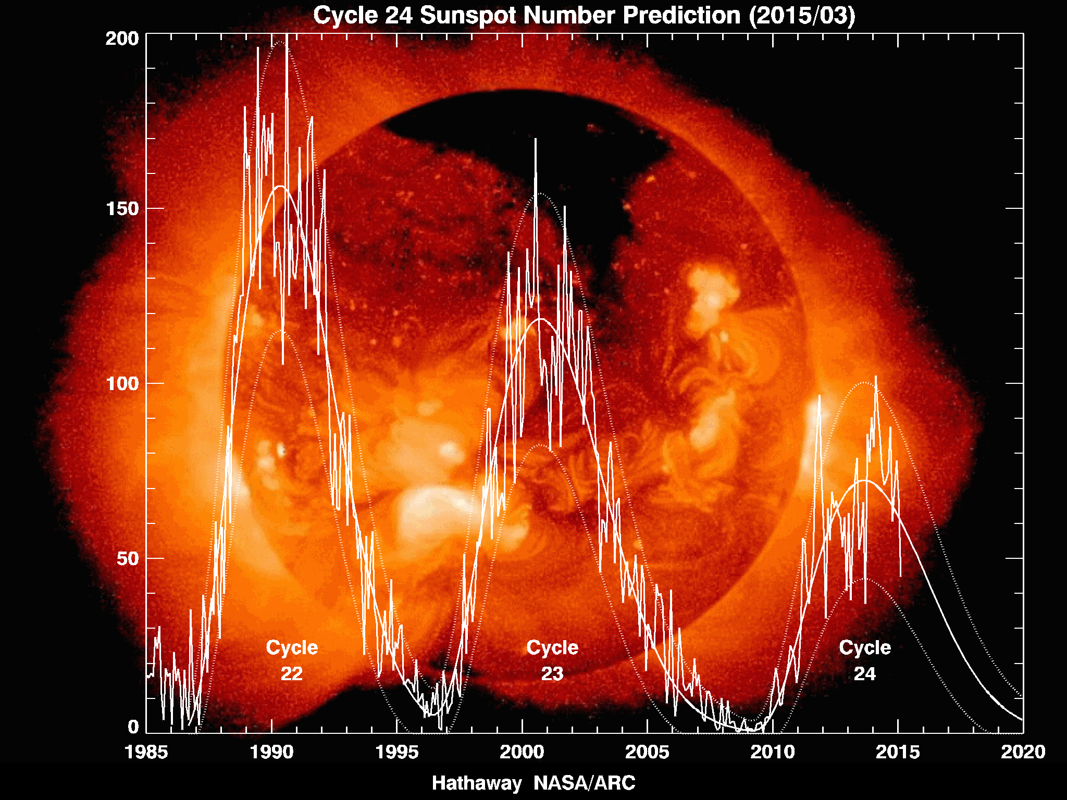
Figure 1. Sunspot number as a function of year for solar cycles 22 thru 24. The plot shows both the observed sunspot numbers as well as the smoothed median sunspot numbers, projected out to the year 2020. Source: http://solarscience.msfc.nasa.gov/images/Cycle22Cycle23Cycle24big.gif
. Sce:http://solarscience.msfc.nasa.gov/images/Cycle22Cycle23Cycle24big.gif
http://solarscience.msfc.nasa.gov/images/Cycle22Cycle23Cycle24big.gif
- Equations: Equations should be numbered. Please enclose the number in parentheses, and place it flush with the right-hand margin, e.g.,
$N_{T}=\int_{R}^{S}{N_{e}ds}$(1)

- Tables: Use bold, 11 pt Times New Roman font or equivalent. e.g,

Title1 | Title2 | Title3
Label1 | 1 | 0.3
Label2 | 5 | 0.5
Label3 | 20 | 900
Table 1 Example of a table caption
- References: List and number all bibliographical references at the end of the document in alphabetical order according to the last name of the first author. When referring to them in the text, type the corresponding reference number in square brackets as shown here [1]. For example:

[1] Di Giovanni, G., Radicella, S.M., (1990). An analytical model of the electron density profile in the ionosphere, Advances in Space Research, Volume 10, Issue 11, Pages 27-30, ISSN 0273-1177.

[2] Klobuchar J.A., Doherty P.H., Bailey G.J., Davies K.,(1994). Limitations in Determining Absolute Total Electron Content from Dual-Frequency GPS Group Delay Measurements. Beacon Satellite Symposium, Aberystwyth, July 11-15.

[3] Nava, B., Coisson, P., Radicella, S.M., (2008). A new version of the NeQuick ionosphere electron density model, Journal of Atmospheric and Solar-Terrestrial Physics,doi:10.1016/j.jastp.2008.01.015.

- Acknowledgements: Authors may acknowledge the contributions of non-coauthors and/or the source(s) of funding for their work.

